[Publish Date]
Luis D. Garcia, Mark M. Hanna, Chloe M. Keiran, Caleb W. Mears,
Maria A. Rojas, Caden B. Schwartz
FAMU-FSU College of Engineering 2525 Pottsdamer St. Tallahassee, FL. 32310

Team 522: Rockwell Automation - Automated Manufacturing Device for Students

Abstract
For this project, our team is partnering with Rockwell Automation, an industry leader in technology services. The project's purpose is to show the steps of automated manufacturing to K-12 audiences. Team 522’s mission is to educate students about the manufacturing process and engage students on STEM (Science, Technology, Engineering or Mathematics) topics. The team is designing a system that will build a metal pin. This system was chosen by the team for its efficiency in demonstrating various manufacturing stages. A specific goal of this system is for it to produce one pin each minute and also be safe for the children who are viewing. The system consists of stations that show different processes related to common steps in manufacturing. One step is user personalization where a student can insert a unique design into the system, the system will use a sensor to check if the design fits the preset rules. This demonstrates the ability of the system to quality control its inputs and outputs, a fundamental step in the manufacturing process. The system can display the various steps of manufacturing on a screen at the same time as the machine is processing the metal pin, keeping the user engaged by describing each step of the process. The design uses computer-aided design and testing software such as CAD and emulate3D. The physical model uses Rockwell hardware alongside other parts. The end goal of this project is to produce a system that Rockwell will be proud to showcase and use for engaging the public in automated manufacturing.
Disclaimer

Acknowledgement
These remarks thanks those that helped you complete your senior design project. Especially those who have sponsored the project, provided mentorship advice, and materials. 4

- Paragraph 1 thank sponsor!
- Paragraph 2 thank advisors.
- Paragraph 3 thank those that provided you materials and resources.
- Paragraph 4 thank anyone else who helped you.

Table of Contents
Abstract 2
Acknowledgement 2
Table of Contents 3
List of Tables 4
List of Figures 6
Notation 6
Chapter One: EML 4551C 9
1.1 Project Scope 9
1.2 Customer Needs 11
The answers received by the advisors helped establish the principal goals of the project. The device created will need to demonstrate the process of manufacturing a product while being interesting and educational for students of all ages. For this purpose, the entire process can consist of a controlled cycle that will move fast enough to keep the audience engaged and produce an item with the Rockwell branding which the students can take home. 14
1.3 Functional Decomposition 14
1.4 Target Summary 19
1.5 Concept Generation 29
1.6 Concept Selection 34
1.8 Spring Project Plan 40
Chapter Two: EML 4552C 41
2.1 Spring Plan 42
Project Plan. 42
Build Plan. 42
Appendices 43
Appendix A: Code of Conduct 44
Appendix B: Functional Decomposition 50
Appendix C: Target Catalog 51
Appendix D: Concept Generation 54
Personal Engraving 54
Appendix D: AHP Design Alternatives 60
Appendix B Figures and Tables (delete) 62
Flush Left, Boldface, Uppercase and Lowercase 64
References 64

List of Tables
Table 1. Customer Needs Table 3
Table 2. Functional Decomposition Cross Reference Table 7
Table 3. High Fidelity Concepts Table 22
Table 4. Medium Fidelity Concepts Table 23
Table 5. Binary Pairwise Comparison 25
Table 6. House of Quality 27
Table 7. Pugh Chart 29
Table 8. Criteria Comparison Matrix 30
Table 9. Normalized Criteria Comparison Matrix 30
Table 10. Consistency Check 31
Table 11. Final Rating Matrix and Alternative Value 32
Table 12 The Word Table and the Table Number are Normal Font and Flush Left. The Caption is Flush Left, Italicized, Uppercase and Lowercase 50

List of Figures
Figure 1. Functional Decomposition Hierarchy Chart 7
Figure 2. Flush left, normal font settings, sentence case, and ends with a period. 48

Notation
A17 | Steering Column Angle
A27 | Pan Angle
A40 | Back Angle
A42 | Hip Angle
AAA | American Automobile Association
AARP | American Association of Retired Persons
AHP | Accelerator Heel Point
ANOVA | Analysis of Variance
AOTA | American Occupational Therapy Association
ASA | American Society on Aging
BA | Back Angle
BOF | Ball of Foot
BOFRP | Ball of Foot Reference Point
CAD | Computer Aided Design
CDC | Centers for Disease Control and Prevention
CU-ICAR | Clemson University - International Center for Automotive Research
DDI | Driver Death per Involvement Ratio
DIT | Driver Involvement per Vehicle Mile Traveled
Difference | Difference between the calculated and measured BOFRP to H-point
DRR | Death Rate Ratio
DRS | Driving Rehabilitation Specialist
EMM | Estimated Marginal Means
FARS | Fatality Analysis Reporting System
FMVSS | Federal Motor Vehicle Safety Standard
GES | General Estimates System
GHS | Greenville Health System
H13 | Steering Wheel Thigh Clearance
H17 | Wheel Center to Heel Pont
H30 | H-point to accelerator heel point
HPD | H-point Design Tool
HPM | H-point Machine
HPM-II | H-point Machine II
HT | H-point Travel
HX | H-point to Accelerator Heel Point
HZ | H-point to Accelerator Heel Point
IIHS | Insurance Institute for Highway Safety
L6 | BFRP to Steering Wheel Center

Chapter One: EML 4551C

1.1 Project Scope
Project Description
Rockwell Automation is interested in engaging wider demographics on the automated manufacturing process. This project aims to develop a system that can showcase an automated manufacturing process that creates an educational item. The automated system designed should educate and engage students about the manufacturing process.
Key Goals
The key goals present will serve as outlines for measuring proper achievement of the project’s mission throughout the project timeline. The first goal is for the device to showcase the automated manufacturing process. The second goal is for the automated manufacturing process simulation to provide an educational experience to any present viewers. The third goal is for a tangible educational product that includes the Rockwell logo to be produced by the process that can be distributed to present viewers.
Markets
The primary market of the project caters to Rockwell Automation and their needs. This will be a visual learning device that Rockwell can use to spark the interest of K-12 students. The secondary markets, unlike Rockwell, are uninvolved with the development and therefore must be capable of viewing the system and comprehend what automated manufacturing looks like on a smaller scale . The most important secondary market is the students the system will be showcased to as their feedback to the system will determine the success of the system. Another secondary market could be the FAMU-FSU College of Engineering where the device could be used to stimulate interest in the automated manufacturing process, as well as manufacturing engineering. The last secondary market this project might appeal to could be local youth STEM programs that could use the system as an engaging visual showcase for adolescents passionate towards STEM.
Assumptions
For this project to be operated safely, it has to be assumed that an adult is going to be supervising the process for the entire demonstration time. It should also be assumed that the students might touch the device, therefore, it should be designed accordingly to maintain safety as a priority. Since the device will be used to showcase in various locations, it can be assumed that the entire device must be mobile. Since there will be someone educating the students on the automated manufacturing process while the system is running, the system must not be too loud and not drown out the speaker.
Stakeholders
The stakeholders related to this project consist of the individuals and groups that assisted time, advice, and resources into the project. The main stakeholders in the Rockwell Automation device include Tajaey Young and Amanda Easton as Sponsors from Rockwell Automation, Dr. Jerris Hooker as Advisor from FAMU-FSU College of Engineering, and Dr. Shayne McConomy as Senior Design Instructor at the FAMU-FSU College of Engineering. Rockwell invited a tech support member, Shayla George, to aid in our teams Rockwell software support and overall technical advising.

1.2 Customer Needs
Rockwell Automation seeks to develop a model aid to help demonstrate the automated manufacturing process and is collaborating with the FAMU-FSU College of Engineering to achieve this. This is the first year in which Rockwell Automation is engaging in such a collaboration with the FAMU-FSU College of Engineering with Taejay Young and Amanda Earson serving as the primary advisors from Rockwell Automation for this project. Rockwell Automation will be the primary customer for this project as we are designing it for their use. We asked the following questions to Young and Earson to further clarify the needs of Rockwell for this device.

Table 1. Customer Needs Table
Question | Customer’s Response | Interpreted Need
What are the restraints in terms of size and weight? | Since the product will be used multiple times at various locations, it must be mobile. | Individual pieces must be under 30 pounds. (can be made in sections)
Is there anything that has to be included in the final design? | Any software or hardware used in the project should be made by Rockwell. | Use Rockwell hardware and software whenever possible.
Where will this product be showcased? | Mostly used in events for K-12 but might be used in a career fair. | Engaging and interesting for all ages.
What shall the outcome of our product be? | We would like the project to create a physical item that the viewer can take home with them that promotes Rockwell. | Output of project ought to incorporate Rockwell.
Are there any assumptions that need to be made about the final product? | We are leaving most of the concepts and the final design up to you, but the final design must be safe for the children who want to touch everything as well as interesting and useful for them. | Safe for all ages.  Product ought to be consumer focused (product for students).
If we decide to make the project modular, what kinds of things would you be looking for? | We would like to make it as simple as possible whether that means a single connection point between each module or have things color coded. | If made modular, be as simple as possible to assemble.
Is there an ideal range for the project’s manufacturing time? | Too slow is not ideal but too fast is fair so long as the process repeats. | The manufacturing process shown moves fast enough to keep the audience engaged.
Is the device continuously producing at all times? | It should be a continuous process to repetitively show the steps but can have a start-stop mechanism to not overproduce. | Device can have a controlled continuous cycle.
Is there any part of the instructional process you hope to not be taken over by the model? | You should not be too worried by what the product takes away from instruction. | The project can coexist with an instructor but takes precedence over instructor.
Are there any aesthetic or branding requirements for the project? | The manufactured product should have Rockwell branding but the device itself does not need it. | Manufactured products have Rockwell branding.

The answers received by the advisors helped establish the principal goals of the project. The device created will need to demonstrate the process of manufacturing a product while being interesting and educational for students of all ages. For this purpose, the entire process can consist of a controlled cycle that will move fast enough to keep the audience engaged and produce an item with the Rockwell branding which the students can take home.
This device is intended to be used at multiple locations; therefore, the entire structure will be mobile and lightweight for the ease of transportation. The entire manufacturing device will be divided into modules which will need to be easy to assemble, and each individual module will weigh less than 30 lbs.

1.3 Functional Decomposition
A functional decomposition was performed in order to break down the entire system that needs to be designed into smaller components or subsystems. For better understanding and organization of the device being created, a hierarchical decomposition and a cross reference table are included below.
Data Generation
The data used as the foundation of the functional decomposition was obtained during multiple Microsoft Teams meetings with our sponsors, Tajaey Young and Amanda Eason. The questions asked were designed to provide a baseline of expectation for what the device needs to achieve. The answers to the questions are cataloged and documented in the previous section of this Evidence Manual. These determined customer needs shaped the entire system which was then broken down into functions and subsystems necessary to have a successful device for our project.
Figure Introduction
The determined functions and subfunctions are referenced within the hierarchal flowchart and the cross-reference table to show how they relate to each other and to the overall system.
The hierarchal flowchart shown in Figure 1. visualizes the relationship between levels of functions by showing lower functions as branches of the higher functions above them. Four main functions were found to be essential for our device: Control, Support, Manufacture and Educate. These four were then further divided into smaller components or subfunctions that will eventually come all together to accomplish the goals of the project.
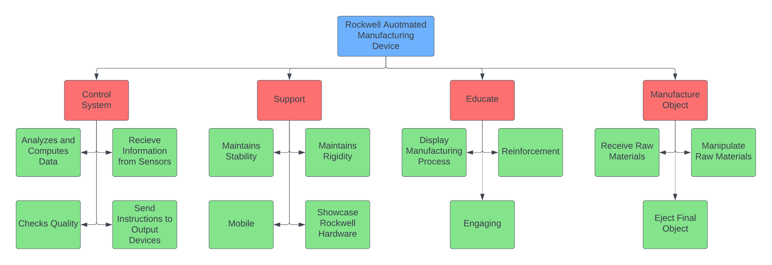
Figure 1. Functional Decomposition Hierarchy Chart
The cross-reference table demonstrates the same relationships from the chart above but in table format with functions in the first column and systems in the first row. The relationships between functions and a system are shown by an ‘X’ in the common box between the two.
Table 2. Functional Decomposition Cross Reference Table
 | SYSTEM
FUNCTION | CONTROL | SUPPORT | EDUCATE | MANUFACTURE
Receives Information from Sensors | X
Analyzes and Computes Data | X
Sends Instructions to Output Devices | X
Checks Quality | X |  | X
Maintains Stability |  | X
Maintains Rigidity |  | X
Mobile |  | X
Showcase Rockwell Hardware |  | X
Display Manufacturing Process |  | X | X
Reinforcement |  |  | X
Engaging |  |  | X
Receive Raw Materials |  | X | X | X
Manipulate Raw Materials | X |  | X | X
Eject Final Object | X |  | X | X
Smart Integration
Many of the sub-systems of the device will influence different required functions in varying degrees. The Educate and Manufacture functions of the device will experience a notable amount of overlap in affecting the various subsystems since the primary topic of education is manufacturing: the way in which the manufacturing subsystems interact will affect the way in which the Educate function is achieved. Another cross sub-system relationship notably present is between the Control function and the Manufacture function, this relationship is to be expected from an automated manufacturing process as the communication of digital information is crucial in the entire manufacturing process when it is automated. The relationship between Support and Manufacture will be important as the device will need to take in raw materials for the manufacturing process and such inputs will be an additional volume and weight consideration for the structure of the device.
Action and Outcome
For the device to satisfy all of the customer needs established it will need to Educate the audience by displaying the manufacturing process and engaging them during the demonstration. To show this process the device will need to Manufacture an object by taking in raw materials, manipulating these materials and eject the final product. To ensure this process is automated from start to finish, it will need to Control each station using a control system that will receive information from sensors, analyze and compute this data and send instruction to the output devices at each station and perform the desired manipulation to the material. Before ejecting the object, the device should check for quality aspects of the item and reject the sample if it does not comply with the standards. While all of these functions are being done by the system, the structure should support all of its components and maintain stability and rigidity while being stationary or being moved from place to place. All these components should also be completely mobile and showcase the Rockwell brand and its hardware.

1.4 Target Summary
Functions and Targets/Metrics
From our functional decomposition, we identified four major functions that our system must complete to accomplish the outlined goals. These four main functions are Control, Support, Educate, and Manufacture. From these main functions we determined 14 subfunctions that fit into one or more categories of main functions. We also determined how the functions will be validated and outline specific values for our design criteria to meet. The fourteen subfunctions determined through this analysis are receives information from sensors, analyzes and computes data, sends instructions to output device(s), checks quality, maintains stability, maintains rigidity, mobile, highlights Rockwell hardware, display manufacturing process, reinforcement, engaging, receives raw materials, manipulates raw materials, and ejects final object. Targets are the numerical values outlined below that quantify the success or failure of each of these functions. Metrics are the physical property (units) of the quantification, like temperature or force.
Method of Validation
In this project we aim to create an integrated manufacturing and education system that allows students to learn about manufacturing processes through hands-on experience. To ensure the success of the project, it is essential to validate the system's performance and effectiveness. This validation method outlines specific testing methods and discusses how they will be used to evaluate targets and metrics.
Performance Testing aimed at assessing the system's manufacturing capabilities. Its key objectives are to measure the system's accuracy, efficiency, and material compatibility. Tolerance and Precision Testing meticulously assesses the manufacturing equipment's accuracy, which includes cutting, shaping, and assembly processes. Meanwhile, Production Speed Testing evaluates the system's efficiency by quantifying the time required to complete manufacturing tasks. Material Compatibility Testing examines the system's adaptability to different materials, especially metals, to ensure it can meet diverse manufacturing needs.
Educational Testing focuses on assessing the effectiveness of the education component within the system. Its objectives encompass evaluating knowledge retention, gathering qualitative feedback, and assessing practical application. Knowledge Retention Testing employs pre- and post-tests to measure how effectively students grasp manufacturing concepts after using the system. Student Feedback and Surveys provide a valuable qualitative perspective by collecting data from students through surveys and interviews. Performance Assessment evaluates students' ability to apply manufacturing principles they've learned through the system to practical scenarios, reinforcing the practical applicability of the educational component.
Safety Testing is integral to the project, with the primary aim of ensuring the safety of students and operators when using the system. It involves identifying potential hazards, assessing their severity, and implementing mitigation strategies.
Cost Analysis seeks to determine the cost-effectiveness of the integrated system. This is achieved through Cost-Benefit Analysis, evaluating the overall costs incurred during system implementation and comparing them to the educational and manufacturing benefits, ensuring the project's financial viability.
Lastly, Usability and User Experience Testing focuses on evaluating the system's user-friendliness and overall user experience. User Testing, featuring feedback from students and operators, is instrumental in identifying usability issues and areas for improvement, ensuring the system is user-centric and effective in facilitating learning. In sum, this comprehensive validation approach ensures that the integrated manufacturing and education system not only meets the highest performance standards but also delivers an effective, safe, cost-efficient, and user-friendly learning experience for students.

Derivation of Targets/Metrics
For each function, the corresponding targets and metrics were determined after extensive research and discussions between the sponsors and teammates. The control function was given a specification on the minimum response time for the sensors that will be used for the device. It was determined that the sensors should have a response time of 5ms or less for an effective and quick cycle which was based on the average response times for the Rockwell sensors that will be used. Based on the control subfunction of quality check, it was also determined that there should be a passing rate of at least 75% of the items to quantify how well a process can reproduce product the items satisfactory to the customers. This target was assigned based on the common quality requirements for a manufacturing process and discussed by the group where it can be shown how 1 out of 4 products fail the quality check and educate on this important part of the process.
The support function has a main target of an approximate weight per station of less than 30lb/13.6kg along with other general targets such as a yield strength of 10 MPa and a Youngs Modulus 1 GPa. These specifications were determined by the average strength of an adult which is the assumed person that will be handling the device. The educate function has a main target consisting of the average quiz score that will be given to the audience after the demonstration. This score should be greater than 70% which is the most common passing grade for the standard school in the United States.
For the manufacture function of the system a few targets were set to help determine what a successful process would be like. It was determined that the cycle time per item must be under 2 minutes from when the input material is inserted into the device until when the output product is produced. Also, there must be 3 modifications to the product per minute. These targets and metrics were determined based on the customer needs specified in the previous section which required a continuous and quick process per item to keep the process interesting and efficient.
Control Targets and Metrics
For the system to work correctly we must implement a control sub-system. This will be the brains of our overall system and control the flow of outputs based on given inputs. The controls will be broken down into various functions to achieve the required goals. The control system must be able to receive information data from sensors, then analyze and process that data, and send instructions to an output device. Another function it must do is, check the quality of process during the entire time of operation. The control system must also handle manipulating raw materials and ejecting a product at the end of the demonstration.
The sensors must operate for a certain period of time, the range of time for a response from any sensor must be between 1 and 5 (ms). This system will contain multiple sensors with different response times, so a range of values is being used. Additionally, each sensor will have a minimum required operating voltage and again a range of voltages will be established as a target for all the sensors, the range is 10-30V DC.
The control system will also have a programmable logic controller (PLC) which will act as the medium for controlling the input/output data. For this system to operate efficiently, and accurately there must be an established minimum computation time for the PLC. The minimum computation time is 0.30 (µs) per basic instruction. A second target for the PLC is that the controller must have a minimum of 35 input/output ports so we can accommodate all sensors and GUI configurations.
For the system to accurately check quality there must be a defined final object that is being produced. Once this item is chosen the targets for checking quality will be checking for a range of specified dimensions or checking for a certain number of parts within a bin. Some quantitative measure of the produced item's accuracy is crucial to meet this project's requirements.
Finally, the control system will have to handle the manipulation of raw materials, which will require the system of controllers and sensors to work cohesively to analyze weight and geometric factors related to the material. The same requirements hold true for the system to eject a final product at the end of the demonstration, which will require at least one full iteration of the system takes place every 5 minutes.
Support Targets and Metrics
For the system to function properly, the system itself must have stability so the whole thing does not break. In the automated manufacturing process, one of the key things is repeatability but more importantly the result must have a high degree of accuracy. This requires the system to have a higher strength and rigidity to try and avoid any small movements, shifts, or shaking that would disturb the accuracy of the product itself.
When looking at materials for the load bearing support structure, we want to ensure we are using materials with a high Youngs Modulus. This measures the ability of a material to not change in length under compression or tension. This Youngs Modulus should be at least 1 GPa, so we can rule out materials like foam and elastomers that tend to compress under a weight which would affect our product accuracy.
This system will have moving parts on it and anything that moves has a force involved if it accelerates from still to moving. The system's structure must have high enough strength to maintain rigidity when exposed to these forces to not deform or fracture completely. This strength must be greater than 10 MPa, which also takes out materials like foams and certain elastomers.
When put under the force of weight and the moving parts, this puts stress on the support. Since this is going to be used for a while and will be constantly running at events, the material needs to have a high fracture toughness. Repeated and prolonged stress on the support structure could potentially cause cracks to form and the resistance of these forming and the spreading of the cracks leads to failure, so a higher fracture toughness is needed. A fracture toughness of at least 10 MPa*m^½ will allow for a strong and long-lasting support structure. The target fracture toughness does not necessarily fall under a specific function but is still an important target to have when trying to figure out what material and set up to use for our support structure.
Let it be noted that when choosing a material to use for the support structure, the targets will be followed but not every material that falls under these categories will be usable due to things like price, density, and the make-up of the material itself. Diamond is a material that will meet these requirements but will be too expensive and heavy due to its high density. Also, some of these materials will be brittle, making them unusable for this application.
Lastly, when setting a target for the weight of the system, a few things need to be considered. Our system will either have wheels and can be rolled around, or it will have handles and it will be carried around. When producing target weights for both cases, we want to plan for worst case scenario with a factor of safety so the smaller mass will be taken. Based on the estimated size of the system, the most efficient way to carry it would be around elbow height and with handles, and on average a man can handle around 55 pounds and a woman can carry around 35 pounds. So, giving us a buffer and picking the lower number, we can say that if this would be carried the maximum weight would be 30 pounds. The other option is to attach wheels to the system allowing it to be rolled. If it were to be rolled into a building, we have assumed that the building would follow ADA guidelines and have a ramp with a slope of around 5 degrees so the system can be rolled around with no issues. The average man can push around 100 pounds and a woman around 80 pounds. When we account for pushing up the ramp with 5 degrees and giving it a factor of safety, these numbers change to 85 and 70 pounds for a man and a woman, respectively. For our case we are going to account for the lowest weight, so our target weight for each section is going to be 30 pounds.
Educate Targets and Metrics
For the device to achieve our main objective of educating students, we need to set what our functions are supposed to target. These functions include display manufacturing process, reinforcement, and engaging. When displaying the manufacturing process, the system should have a window or screen that shows the steps of the item being produced. One example could be stack lights that indicate the device’s status. Red could represent a stop in the process or moving to the next part. Green could indicate the station has finished or the product has finished building. There could also be a screen that shows the steps of the process, the status, and possibly a description of the station for the audience to understand.
For reinforcement and engagement, the device needs to show the manufacturing process to people who have no prior knowledge; therefore, we need a way to measure how much they learned from the device. The target we decided would be a quiz or survey that the student would take before and/or after the process. It would measure how much they learned, if any, and how interested they were in the subject. We decided this measure would be if quiz scores were greater than 70%, they learned more of the manufacturing process than prior to the device. This target and measure apply to both reinforcement and engagement because when people are engaged or focused, they will retain more information than if they were not.
Manufacture Targets and Metrics
For the system to achieve its goal of manufacturing an item for the audience, it must achieve multiple functions related to the manufacture task. Manufacture functions include receiving raw materials, manipulating raw materials, and ejecting a final output. The manufacturing process will occur throughout multiple stages similarly to a real-world automated manufacturing process with each stage making a considerable manipulation to the input before ejecting the output at the final stage. The manner in which the raw materials are taken in should be clearly discernible to the audience that is being educated and the system should also be capable of carrying a designated amount of raw materials given to it. To receive raw materials, the system should be capable of taking in and bearing a sustained load from the raw materials; a target of 2 kgs of input support was determined as the manufacturing process will not be able to occur if the system cannot intake raw materials properly. This chosen target will be a function of the material and geometry of a given design.
For the system to manipulate the given materials, it should be capable of altering the given material at various stages by means of sensors and qualitative modifiers at a quick rate to ensure a constant rate of output; a target of at least three modifications per minute-station was determined to ensure that the manufacturing process will continuously alter the raw materials passing through it at a rapid but observable rate. Any type of action sent from the system and received by the material that modifies the material in a noticeable way will be considered a modification, the number of modifications made to the material will be helpful in indicating progress of the assembly. Breaking up the cycle into actions taken per minute will also be helpful in demonstrating the capabilities of automation in manufacturing as having a number of actions per minute to compare with a human attempt will be a useful metric.
For the system to eject a final output, it should be capable of completing each stage of the manufacturing process of the given item in a timely fashion; a target of less than one minutes per cycle was determined to ensure that the manufacturing process was being completed and thus a final output was being ejected. The cycle time will be a crucial metric for qualifying the success of the system as it should ideally be manufacturing in quick iterations to work in tangent with any efforts to educate on the manufacturing process.
Targets and Metrics Outside of Functions
A target and metric that addresses three other needs not listed is an approximate 50% of cycle time interactions. Although it does not fall under a function, this describes how many interactions are within our current cycle time of less than 5 minutes but could change based on any sub function change.
Summary of Critical Targets and Metrics
After defining every target and metric we considered essential for our device, a few of these were determined to be critical for the project since it would fail completely without these main specifications shown in the table below.
Table 3. Critical Targets and Metrics Table
FUNCTION | TARGET | METRIC
Control | Response time of sensors: <5ms | Time
Support | Weight per station: <30lb/13.6kg | Weight
Educate | Quiz score: >70% | Quiz Score Average
Manufacture | Cycle time per item: <5min | Time/Cycle
Firstly, to successfully control the process, the implemented sensors should have a response time of less than 5ms. This will ensure that the sensors are providing real time data about the state and conditions of the product at any point in the process and correct any errors immediately. This will enhance the optimization of the process while ensuring a higher quality of the product and a smoother cycle.
Secondly, for the support of the entire assembly, each station should weigh less than 30lb/13.6 kg since it is meant to be designed to be moved from place to place by a single adult and it should ensure safety for the carrier as well as stability and rigidity for all the components contained in each module. This will allow for easy transportation while preventing any damage to the components and/or users.
Thirdly, the overall main purpose of the entire project is to educate students on what we are showcasing and to measure the success of this device the audience will be provided with a quiz at the end of the demonstration to validate the effectiveness of the project. For this reason, a passing score of at least 70% in average is required to have a successful educational device.
Lastly, for a continuous and iterative manufacturing process it is critical for it to also be as fast as possible to keep the audience engaged and produce and have higher productivity. For this purpose, the cycle time should last less than 2 minutes which allows for more engagement and attention from the viewers who might lose interest if the cycles are too slow and demonstrating how time efficient is an automated process compared to a regular manufacturing of a product.

1.5 Concept Generation
Concept generation is a tool used in engineering design to produce potential solutions to the problem outlined in the sections above. The team generated 100 concepts using multiple different techniques, such as brainstorming and the crap-shoot method. The full concept generation list is shown in appendix D. From the list of 100 concepts, 5 medium-fidelity designs were selected, and 3 high-fidelity designs were selected. Medium-fidelity designs can fulfill the project's needs, but high-fidelity designs can accomplish a wider range of the outlined goals. The high and medium-fidelity designs are outlined below in tables 4 and 5 respectively.
Concept Generation Methods
Different methods were employed to generate one hundred concepts for the manufacturing system. Before concept generation could begin on a manufacturing device, the item being manufactured was a primary topic of discussion. Prior conversations with the sponsors established that the manufactured item had to be “consumer-friendly” and engaging to K-12 audiences. With these requirements set and some preliminary research into commonly mass manufactured items completed, the team came up with twenty potential items to design a manufacturing system for. The team met with the sponsor to discuss and evaluate the twenty potential items and the following five were selected by the sponsor as the highest value items for their needs: a penny smasher, personal engraving, an electronics kit, a toy car, and a metal pin.
Twenty concepts were conceived for each of the five items resulting in a final count of one hundred concepts generated. The personal engraving concept was open-ended as various items for engraving and methods of engraving were discussed; for this item, the crap shoot method of concept generation was utilized using a two four-sided die and a six-sided die. The dice were used to decide what was being engraved, the item being engraved upon, and the method of engraving. For the rest of the items, brainstorming was utilized with various methods coming into play during the process like forced analogy, such as in concepts 45 (clapping monkey button maker) and 73 (cake analogy electronics kit), or SCAMPER, such as in concepts 29 (reciprocating hammer penny smasher) and 80 (puzzle produced by rotating bin system).
Table 3. High Fidelity Concepts Table
High Fidelity Concepts
Concept # | Description
41 | Metal Pin: A moving assembly system with paper design.
80 | Electronics Kit: Produce puzzle that has a functional circuit with LED and pushbutton with a rotating bin system (like soup scene in Ratatouille).
100 | Toy Car Kit: Box with chassis, body, engine, transmission, etc. Make a “punch out” model of a car using a press.
The first high-fidelity concept involves a precision metal pin assembly system, where a paper design is inserted and then pressed into a button top and bottom. For this first high-fidelity concept, the viewer would be given a small, circular sheet of paper with the Rockwell logo on it with the prompt of drawing on the blank sections. The papers would then be inserted as inputs into an assembly line system through which it would pass three sections before being ejected as a completed button for the viewer to keep. If the viewer drew over the Rockwell logo, the button would be rejected and separated from the rest of the final output.
Another high-fidelity notion involves an electronics kit featuring a functional circuit with LEDs and pushbuttons, accompanied by a rotating bin system. The rotating bin system will disperse various common electronics kit items into a prepared bin that will be attached to a plug and play puzzle. Upon completing the “puzzle” the user would have a functional LED circuit that outlines the connection points. There will be some degree of personalization with the kits as viewers will be able to choose their respective LED color and other items.
The third high-fidelity concept revolves around a toy car kit, comprising a box with chassis, body, engine, transmission, and more. The process would produce a cardstock “punch-out” of the body of a toy car that could be assembled by the viewer after the manufacturing process. Some miscellaneous items that would be included with the kit are miniature LED lights for the headlights, wheels, and a battery. A similar bin system to the electronics kit was discussed as a potential inclusion with this design as well to disperse these additional items.
Table 4. Medium Fidelity Concepts Table
Medium Fidelity Concepts
Concept # | Description
6 | Personalization engraving: templates on a key chain by branding.
21 | Penny smasher: two cylinders that smash penny and one has different templates with a motor.
45 | Metal Pin: assembly of top and bottom pins done in an iterative fashion.
63 | Electronics kit: resistor color sorting.
84 | Toy car: chassis, transmission, engine, body (all picked by user).
The first medium-fidelity concept is a personalization engraving of different templates on keychains by branding. This idea consists of a set of designs and logos options that the viewers could choose from to personalize their item. This picked design would be entered to the machine as an input and engraved into a keychain through a branding process.
The second concept introduces a penny smasher with two cylinders, one of which hosts various templates driven by a motor. This concept would involve different premade designs that the user could choose from so the penny could be personalized. It would iterate through different steps of stamping process, from alignment to compression to dispensing a final product.
The third medium-fidelity concept is a metal pin assembled in an iterative fashion using top and bottom pieces. This is different from the high fidelity metal pin concept in that with the moving assembly there will be a precut metal pin that will receive some degree of personalization. Whereas this concept is manufacturing the metal pin itself.
The fourth concept centers on an electronic kit for resistor color sorting. This device would use color and distance sensors to analyze an assortment of resistors and sort them according to the color bands associated with a resistance value. It would eject a final “kit” of resistors and would be a useful tool for electronic hardware development.
Lastly, the fifth concept delves into a customizable toy car. This concept would allow the users to choose different components of the car such as their chassis, transmission, engine, and body components from a selection. The viewers would interact with the machine through a screen or panel located at the start or input area of the assembly line and then the car parts would be put together through different automated assembling processes until the final completed car is ejected.

1.6 Concept Selection
Binary Pairwise
In a binary pairwise comparison, all eight customer needs are examined and compared against each other to determine which is more important. As a standard, row 1, column 1, row 2, column 2, and continued is left with a dash since a need cannot be compared to itself. When the row need is more important than the column need, a “1” was given, otherwise a “0” was given. This resulted in a weight of the customer needs as given in Table 6. The total column on the right is the weight of the customer needs that are used in further concept selection charts such as the House of Quality chart. The total row at the bottom is not used for further tools, but it does show the “negative” weight of the needs.
Table 5. Binary Pairwise Comparison
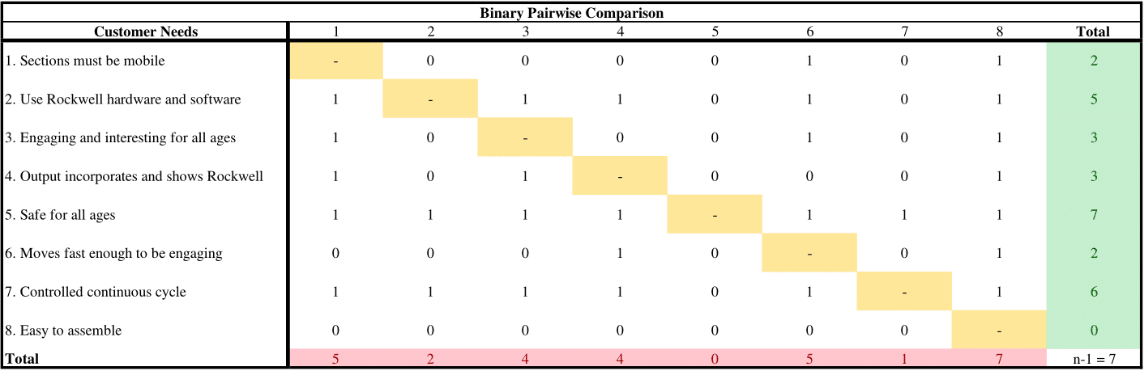
House of Quality
The house of quality (HOQ), shown in Table 7, is a product planning matrix built to analyze the customer requirements and how the customer needs relate directly to our engineering characteristics, targets, and metrics of the project. It uses a biased ranking system to exaggerate which targets are most important based on the needs provided by the project sponsor.
In the far-left column of the HOQ, our customer requirements are listed in no specific order. Opposite of the customer requirements as columns are the engineering characteristics we had in our functional decomposition. These characteristics were deemed to have the greatest impact on our project. From the binary pairwise table results, an important weight factor was determined. Every characteristic has units attached based on our targets and metrics. The weights given in the table are to satisfy the customer needs range from 0 denoting no contribution, 1, 3, 6, and 9 denoting the maximum amount of contribution.
To obtain a raw score, once a weight was given, we multiplied the weight with the importance weight factor and added it by column. The relative weight came from the raw score of the column divided by the total raw score times 100, to get a percentage that equals a total of 100. Each column is then ranked in order by the relative weight percentage. The top 3 engineering characteristics rank order is: displays manufacturing process, maintains stability, and engaging.
Table 6. House of Quality
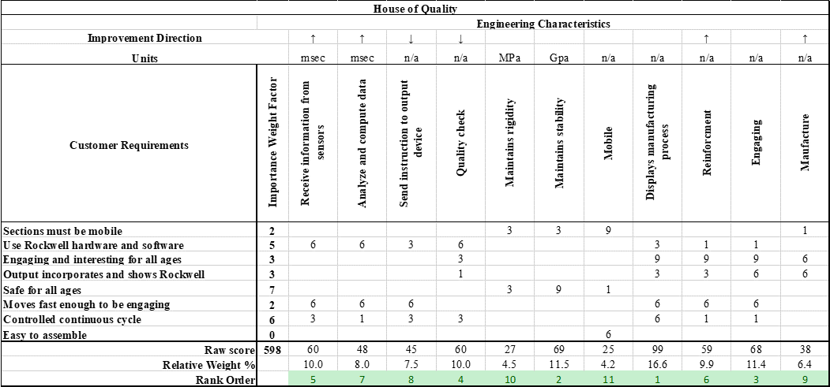
Pugh Charts
Pugh charts are a useful method for analyzing medium and high-fidelity concepts through relative comparisons to current market items. For the current market datum, the Dream Machine Foam Toy Maker manufacturing machine Rockwell showcased to us was utilized as the sponsors used it as an exemplary system of a visually perceivable automated manufacturing. The five highest ranked engineering characteristics found through the house of qualities were the primary characteristics compared between each concept and the market datum. For the first Pugh chart, the three high-fidelity concepts and the five medium fidelity concepts were included and compared to the Rockwell Dream Machine.
For the second iteration of the Pugh chart one concept was chosen as the new datum: Toy car picked by user. Four other concepts that performed well in the previous iteration were compared to this new datum by following the same process from the first Pugh Chart. These concepts were chosen based on the number of pluses and satisfactory they had with respect to the engineering characteristics to further narrow down our set of design ideas. All the concepts in both iterations were satisfactory in respect to their datum in achieving the engineering characteristics of maintaining stability and receiving info from sensors. Half of the concepts in the first iteration were less capable of displaying the manufacturing process than the Rockwell Dream Machine; this characteristic was a crucial one in cutting down on concepts for the second iteration. The personal engraving on keychain and cylindrical penny smasher concepts were promptly eliminated due to their underperformance in the displaying of the manufacturing process and the engaging engineering characteristics. In transitioning to the second iteration, the four concepts with the most combined pluses and satisfactories were chosen for further comparison; both the rhythmic metal pin and resistor sorting electronics kit had the same number of combined pluses and satisfactories but ultimately the rhythmic metal pin continued due to the other metal pin design having the highest number of pluses.
Table 7. Pugh Chart
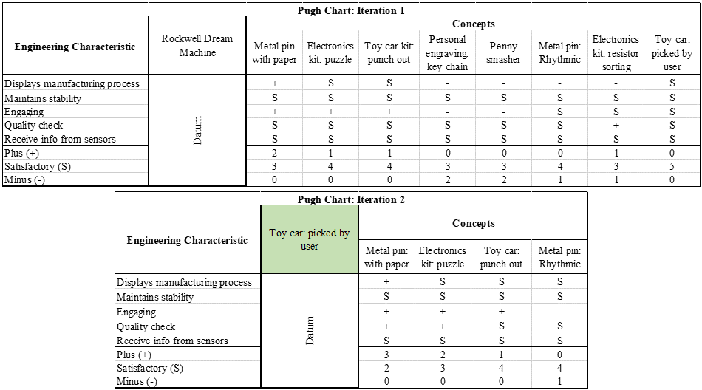

Analytic Hierarchy Process (AHP)
The analytic hierarchy process (AHP) is a tool used to make decisions about ranking the functions of our design. The first step in the process is to use the house of quality matrix to narrow down the engineering requirements for our design to the five most crucial aspects. The five requirements are used to generate a criteria comparison matrix (CCM), shown in Table 9. This table lists fundamental requirements that the system must satisfy and compares them numerically using a ranking system of odd numbered values from one to nine. A value of one means the comparing criteria is of equal importance, a value less than one implies less magnitude of importance, and a value greater than one implies a higher importance.
From the CCM each criterion is normalized with respect to its sum, which generates a normalized criteria comparison matrix (NCCM), shown in Table 10. The average value of each row of the NCCM is taken and this value is the relative weight{W} of importance for each criterion.
Table 8. Criteria Comparison Matrix
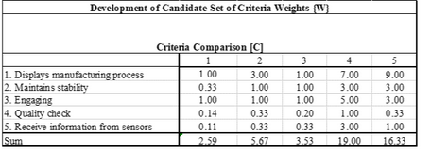
Table 9. Normalized Criteria Comparison Matrix
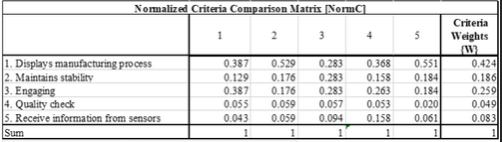
Through this analysis, it was determined that displaying the manufacturing process is our system's most important function so that it can accomplish the project's goals. Maintaining stability and engagement were also determined to be crucial aspects for the project's success. This data is used in the final selection process to outline the relative importance of each function as it relates to each design.
To verify the data obtained through this process and consistency check is performed, shown in Table 11. The criterion and weight values are vectorized and that number is divided by the relative weight of each criterion, which produces a consistency vector. The data yields both yields an acceptable consistency ratio of under 0.01 and the average consistency is close to 6 which is expected. This data confirms that there was no bias in the ranking process and the relative weights of each function are consistent.
Table 10. Consistency Check
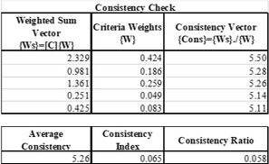
The analytical hierarchy process is then performed for each of the five most important engineering requirements and this data is displayed in appendix E. The process affirmed that displaying the manufacturing process, and engaging are the two most crucial functions. It also helped determine that receiving sensors from data is less important of a function, and that quality control is the least crucial of the five functions. All the rankings provided pertinent information regarding the design of the system and help with the final selection process.

Final Selection
The design chosen by the team is the metal pin with paper (concept 1) shown in Figure _ below, which was determined by an examination and discussion of the three high-fidelity concepts and five medium-fidelity concepts. The design consistently placed first among all concept selection charts and satisfies most customer criteria. All team members agreed that this design not only satisfies the customer's needs and requirements but would showcase our individual skills within the timeline we were given.

Table 11. Final Rating Matrix and Alternative Value
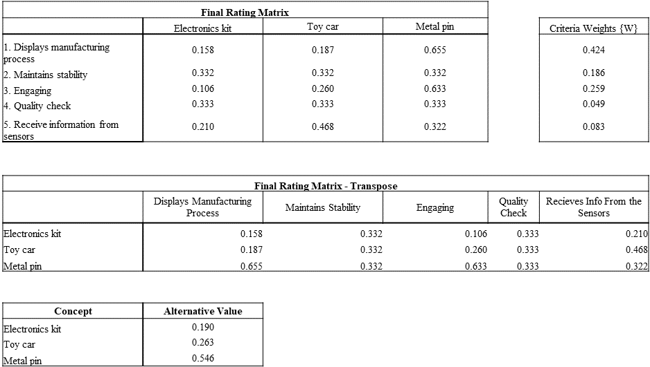

1.8 Spring Project Plan

Chapter Two: EML 4552C

2.1 Spring Plan

Project Plan.

Build Plan.

Appendices

Appendix A: Code of Conduct
Mission Statement

“Empower future engineers through interactive automation education.”
Team Roles
Design Engineer - Chloe Keiran
The design engineer will be responsible for the research and design of a project’s products and systems. The design engineer will use the customer’s requirements to solve problems within regulations. Software such as CAD, Creo Parametric, and more will be used with testing of prototypes to ensure safety, efficiency, and standards are met.
Manufacturing Engineer - Caleb Mears
Responsible for designing and managing all parts and the systems those parts make up. Also manufacturing the parts needed for design. Responsible for making sure the manufacturing
process is carried out in the most efficient and effective way, while still maintaining a high level of quality in parts made.
Test Engineer - Maria Rojas
The test engineer will be responsible for creating proper methods of testing the success
of each metric. The test engineer will then be responsible for conducting these tests and properly recording the results. The test engineer will also identify any problems after conducting tests and make recommendations to the team.
Systems/Dynamics Engineer - Luis Garcia
The systems/dynamics engineer is responsible for the breakdown of the project into multiple subsystems and the compartmentalization of these subsystems into the overall project. The systems/dynamics engineer will work closely with each of the different engineers to ensure information is properly communicated between channels. This role will also work closely on
contributing to simulations of each subsystem and maintaining a log of necessary maintenance.
Electrical Systems/Computer Engineer - Caden Schwartz
The electrical systems engineer is responsible for designing and managing all electrical systems and components. testing and designing applicable circuits and performing analysis on any components involving electronics. The computer engineer is responsible for any coding that arises during the project. The computer engineer is also responsible for selecting an acceptable MCU. The computer engineer will also be responsible for selecting an IDE that can be used by the entire team.

Communication
The main form of communication will be over Microsoft Teams and Outlook email.
Microsoft Teams will be utilized for casual communication, scheduling both in-person and
virtual meetings with other group members, sharing files between group members, requesting
assistance on assignments, and for notices of absence. Outlook email will be utilized for all
communication with the Sponsor/Advisor or Dr. McConomy and the TA’s as well as for
scheduling both in-person and virtual meetings with the sponsor/advisor, scheduling in-person
meetings with Dr. McConomy or the TAs. Slack will be used for general file sharing with the sponsor and for matters that do not warrant a full meeting such as general updates and brief questions. There is an expectation from group members for a response or acknowledgment of the message being read to a Teams message within 24 hours. Group members should check Microsoft Teams and their Outlook email at least three times a day.
Dress Code
Meetings with team members will be casual attire. Sponsor meetings and presentations
will depend on the event and who will be in attendance. Most meetings and all presentations will
be in business casual. Business casual for the men will be black/khaki slacks, a button up shirt, and a tie. Women will wear blazers, button down, black slacks, and closed toe shoes.
Attendance Policy
Every member must attend team meetings when scheduled and contribute to the project
to the best of their abilities. All members must attend sponsor meetings and wear the appropriate
attire. Group members should attend in-class lectures unless given valid reason for missing. If
any member cannot attend meetings, the other attending members will brief/review what was
discussed while the member was away.
Notifying Team
If a member is unable to attend a meeting, they must give an advance notice within 36
hours of the meeting. The group member should send out the notice through an Outlook email to
each of the team members. If the circumstances by which the team member cannot attend is
deemed an emergency, their absence will be excused. The following circumstances are
considered an emergency:
● Personal leave (death, marriage, etc.)
● Medical or sick leave
● Jury duty
Proper Response in Professional Meeting Guideline
Team members will participate in all meetings with the sponsor, adviser and instructor.
During said times ideas, project progress, budget, conflicts, timelines and due dates will be discussed. In addition, tasks will be delegated to team members during these meetings. Repeat absences will not be tolerated. Use proper language such as “sir” and “ma’am” when addressing
sponsors, advisers, and any other superiors. Do not use slang words in a professional meeting
setting. Be respectful of all members and opinions. At the beginning of the meeting the team
should delegate a person to be the note taker for that meeting session. This does not have to be
the same person every time.
Approaching Dr. McConomy or T.A.
Punitive Measures
If a group member is being unresponsive or does not notify the team of an absence, a vote will be taken by the other group members where if four agree to reprimand the unresponsive group member then a message will be sent out to them. A Microsoft Teams message (beginning with DANGER) notifying the unresponsive group member will be sent in the group chat and an acknowledgement of the message will be expected within 24 hours of the message being sent. A supportive group discussion will be held to ensure that the group member will be able to contribute in a way they are capable of. If a group member receives three of these DANGER message notifications in the Microsoft Teams group chat, then a meeting will be held to discuss the greater issues occurring and give the group member a proper chance to explain their circumstances. If a group member receives three of these DANGER message notifications in the Microsoft Teams group chat, then a meeting will be held to discuss the greater issues occurring and give the group member a proper chance to explain their circumstances. The group will then vote on whether the situation warrants Dr. McConomy or the T.A.’s involvement or not; if two or more vote to get Dr. McConomy or the T.A.'s involved, they will be contacted via Outlook email.
Project Matters
If the group is facing an immovable difficulty at any stage in the project process and feel
outside assistance is required, Dr. McConomy or the T.A. will not be contacted until each group
member has given an attempt at the problem. After each member has given an attempt, they will
each sign a form acknowledging that a concerted effort was taken at the problem before
contacting Dr. McConomy or the T.A.
Process for Amending
Amendment must be voted on by all team members and four out of six members must agree on change. Proper reasoning must be provided along with a proper ethical/moral reason.
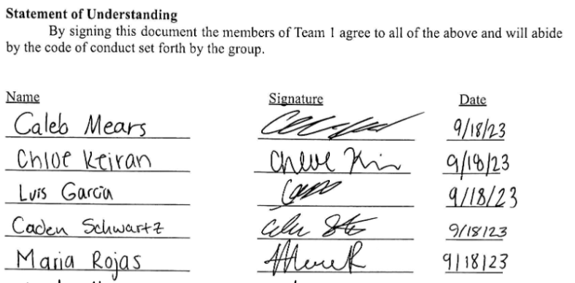

Appendix B: Functional Decomposition

Appendix C: Target Catalog

Functions | Targets | Metrics
Receive Information from Senors | Sensor cycle time between 1ms and 5ms | Time
Analyze and compute data | PLC will take no more than 0.30µs per single instruction | Time
Send instruction to output device | PLC will have >20 I/O ports | # of I/O ports
Quality Check | Quality check passing rate: >75% | Passing Rate
Maintains Rigidity | 10 MPa | Yield Strength
Maintains Stability | 1 GPa | Youngs Modulus
 | 10 MPa*m^½ | Fracture Toughness
Mobile | <30lb/13.6kg | Weight per Section
Displays Manufacturing Process | ≥3 | Steps in Manufacturing Process
Reinforcement | ≥70% | Percent Quiz Score Average
Engaging | ~30% | Percentage of Total Student Interaction
 | ~50% | Percentage - Interacted of Cycle Times
Manufacture | Modifications per minutes: 3 | Action/Time

Appendix D: Concept Generation

Personal Engraving
Personalization | Item | Method
Initials | Dog Tag | Laser
Logo | Block of Wood | Spacer Tracer
Templates | Sticker | Metal Punch
Drawing | Fridge Magnet | Branding
 | Keychain
 | Pencil

Personal engraving trinket:
  - 4, 2, 4 – Drawing, block of wood, branding
  - 2, 6, 3 – Logo, pencil, metal punch
  - 3, 6, 3 – Templates, pencil, metal punch
  - 3, 3, 3 – Templates, sticker, metal punch
  - 1, 1, 3 – Initials, dog tag, metal punch
  - 3, 5, 4 – Templates, key chain, branding
  - 3, 4, 1 – Templates, fridge magnet, laser
  - 1, 2, 4 – Initials, block of wood, branding
  - 1, 5, 1 – Initials, key chain, laser
  - 2, 4, 2 – Logo, fridge magnet, shaper tracer
  - 1, 3, 3 – Initials, sticker, metal punch
  - 2, 4, 4 – Logo, fridge magnet, branding
  - 2, 6, 1 – Logo, Pencil, Laser
  - 3, 6, 4 – Templates, Pencil, branding
  - 1, 4, 2 – Initials, magnet, shaper tracer
  - 3, 2, 1 – Templates, block of wood, laser
  - 3, 2, 4 – Templates, block of wood, branding
  - 3, 3, 1 – Templates, sticker, laser
  - 3, 1, 3 – Templates, dog tag, metal punch
  - 1, 4, 1 –Initials, magnet, laser
Penny Smasher
  - Two cylinders that smash penny and one has different templates with a motor
  - Two cylinders that smash penny and we swap cylinders for different templates with a motor
  - Two cylinders that smash penny and one has different templates with a hand crank
  - Two cylinders that smash penny and we swap cylinders for different templates with a hand crank
  - Hydraulic press with different templates
  - Hand lever that smashes penny
  - Lever with a motor that smashes the penny
  - Heat penny to near melting point and use a hammer
  - Heat penny to near melting point and use reciprocating hammer to flatten penny
  - Just use a hammer on room temperature penny
  - High pressure chamber that compresses penny
  - Heating chamber to warm up penny then smashing chamber to flatten before engraving chambr
  - Heating chamber that melts penny and cool in a puddle
  - Pneumatic system presses penny
  - Spin penny so fast that centripetal acceleration widens penny
  - Use some sort of acid to dissolve penny and let it harden from the puddle copper
  - Use a kitchen roller
  - Use a hot metal point to melt penny layer by layer to flatten it
  - Car jack style hand driven thing that smashes
  - Raises and drops a block that smashes penny over and over
  - Moving assembly system where paper design placed in and is then pressed into button top and bottom
  - Vertically descending system where paper design placed on top pressed onto button
  - Viewers move button through designated stages with alterations made at each stage
  - Viewers draw a design and place it into moving assembly system that either rejects or accepts their design
  - Assembly of top and bottom pins done in rhythmic fashion like clapping monkey toy
  - Viewers race against system in making button with system starting a bit late but still finishing first
  - Rotating operation table with each component being added one by one like the Ratatouille soup scene
  - Use laser to engrave initials
  - User laser to engrave logo
  - Use laser to engrave drawing
  - Use laser to engrave predefined templates
  - Use metal punch to punch initials
  - Use metal punch to punch logo
  - Use metal punch to punch predefined templates
  - Use metal punch to punch drawing
  - Use metal punch to punch Rockwell logo
  - Brand initials on pin
  - Brand templates on pin
  - Brand Rockwell logo on pin
  - Brand drawing on pin

Electronics kit

  - Build a simple circuit out of LED, battery
  - Manufacture a bread board
  - Resistor color sorting
  - Board with button and LED
  - Rotating bin system (like soup scene in Ratatouille)
  - Bins containing components drop parts into a box that is ejected as the kit
  - Self-contained circuit displaying pushbutton
  - Self-contained circuit displaying logic gates
  - Self-contained circuit to power a fan
  - Design a coin counter
  - Thermometer (temperature sensor)
  - Produce Puzzle that has a functional circuit w LED and pushbutton
  - Electronics kit that is analogous to ingredients of a cake
  - Motion activated circuit to turn on motor, LED, etc.
  - Customization with LED lights (greeting card?)
  - Solar panel with LED light
  - Circuit that spins disk that flies
  - Model electronics kit
  - Solar mobile charging kit
  - 72 + 65

Toy Car
  - Chassis, body (picked by user), engine
  - Chassis, body (picked by user), personal engraved, engine
  - Chassis, transmission (picked by user), engine (picked by user), body (template)
  - Chassis, transmission, engine, body (all picked by user)
  - Make a “punch out” model of a car using cnc
  - Make a “punch out” model of a car using laser
  - Make a “punch out” model of a car using a press
  - Rotating hand adds wheels to model car like a pit stop worker
  - Complete car has components screwed in
  - Color for toy car chosen and paint application applied automatically
  - Color, body, mechanical part (educational)
  - Body, color, character driving
  - Fast and Furious car (chosen by user), assembled by device
  - Toy car with logo (rockwell or engineering school)
  - Car with stickers chosen by users (Shapes, letters, drawings, …)
  - Toy car kit (box with chassis, body, engine, transmission, etc.)
  - Toy car with button that lights up an LED.
  - Toy car (chosen by user) that drives
  - Toy car with sounds
  - 87 + 96

Appendix D: AHP Design Alternatives
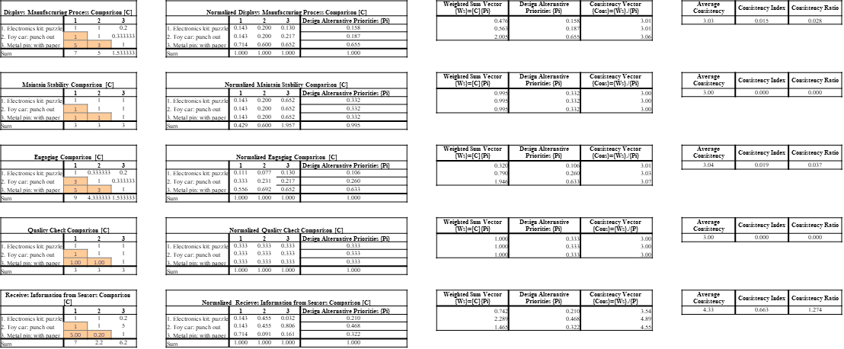

Appendix B Figures and Tables (delete)
The text above the cation always introduces the reference material such as a figure or table. You should never show reference material then present the discussion. You can split the discussion around the reference material, but you should always introduce the reference material in your text first then show the information. If you look at the Figure 1 below the caption has a period after the figure number and is left justified whereas the figure itself is centered.

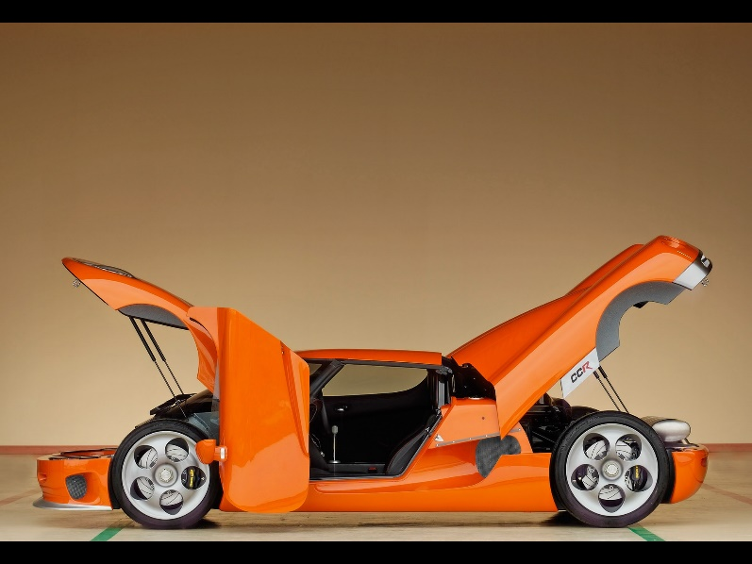
Figure 2. Flush left, normal font settings, sentence case, and ends with a period.
In addition, table captions are placed above the table and have a return after the table number. The second line of the caption provided the description. Note, there is a difference between a return and enter. A return is accomplished with the shortcut key shift + enter. Last, unlike the caption for a figure, a table caption does not end with a period, nor is there a period after the table number.

Table 12
The Word Table and the Table Number are Normal Font and Flush Left. The Caption is Flush Left, Italicized, Uppercase and Lowercase
Level of heading | Format
1 | Centered, Boldface, Uppercase and Lowercase Heading
2 | Flush Left, Boldface, Uppercase and Lowercase
3 | Indented, boldface lowercase paragraph heading ending with a period
4 | Indented, boldface, italicized, lowercase paragraph heading ending with a period.
5 | Indented, italicized, lowercase paragraph heading ending with a period.

References
There are no sources in the current document.

